12.28: Substitution into Eq. (12.14) gives 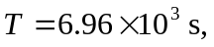 or 116 minutes.

